What is Justice-Oriented Citizenship Education?
The Concentus Citizenship Education K-12 inquiries are designed to cultivate in students a justice-orientation toward citizenship by developing their Essential Citizenship Competencies.
There are 3 predominant approaches to citizenship education, represented here: 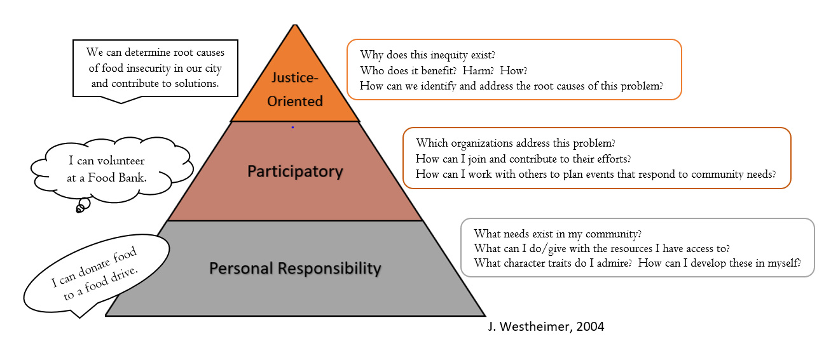
Videos to exemplify each approach to Citizenship Education (click on links)
PERSONAL RESPONSIBILITY | PARTICIPATORY | JUSTICE-ORIENTED
Students practice kindness, generosity, and responsibility in their classroom community. | A student organizes a  group opportunity to care for the environment. | Students engage in a transportation issue that affects their community.  (series of 3 short videos)
While citizens within the first two approaches focus on responding to the symptoms of inequities in the short term, those adopting a justice-oriented approach care for people’s immediate needs and address the root causes of inequities to effect lasting, systemic change. This video helps to clarify this key difference.
To learn more about these approaches, read Joel Westheimer’s 2004 article,
“Educating the ‘Good’ Citizen: Political Choices and Pedagogical Goals.”

To reflect on implications for teaching and learning, read
“The Position(ality) of the Justice-Oriented Citizenship Educator” (link needed)

How Do We Develop a Justice-Orientation? The Essential Citizenship Competencies
Justice-oriented citizens think contextually, critically, and creatively. The Essential Citizenship Competencies (ECCs) support this thinking. There are 5 ECCs. While each has its own knowledge, skills, and disposition, they are interdependent, as this visual illustrates.
Used together, they guide students to a deep,
justice-oriented understanding of a question, topic, or issue.

ENGAGED
ETHICAL
EMPATHETIC
EMPOWERED
ENLIGHTENED
I/WE
- investigate the history & contexts of issues.
- examine power – its sources, forms, and implications.
- seek, understand, & reason fairmindedly from multiple points of view.
- evaluate rights and responsibilities.
- take action that targets root causes.

Why are the ECCs at the heart of Justice-Oriented Citizenship Education?
When faced with a new question, issue, or situation,
our minds like to make sense of things rapidly!

Here’s the problem: If we trust the answer that comes quickly and first, we may be convinced of it because we’ve always believed it, or because it’s in our selfish interest to believe it. If everyone does this, we end up with misunderstanding and conflict! (Adapted from The Miniature Guide to Critical Thinking Concepts and Tools, ” Egocentrism and Sociocentrism”)
Here’s the solution: If we use the ECCs, we can understand the question, issue, or situation more deeply and enter into an “ethical space” of mutually respectful problem-solving. (see Willy Ermine’s article, “The Ethical Space of Engagement”)

ECC Questions to Guide Thinking
ENLIGHTENED
Citizens assume that issues have histories and contexts and seek to understand both.
- What are the Who? What? When? Where? Why? of this situation / dilemma / issue?
- What led to this?
- What are the most important things we need to know to understand this situation?
- How can we find out?

EMPOWERED
Citizens assume that power matters and investigate the sources, forms, levels, distribution, and impacts of power in a given context.
- Who has power in this situation? How do you know?
- Who doesn’t have power in this situation? How do you know?
- What kind(s) of power are involved here, and how does one get or lose it?
- What are the implications of the power distribution for those involved and affected?

EMPATHETIC
Citizens assume that there are multiple, diverse, valid points of view and can reason fairmindedly within and about them.
- Who are the individuals, groups, institutions, & environments involved in or affected?
- How does each one experience and view this situation, problem, or issue?
- What is most precious to each one? Why?

ETHICAL
Citizens assume that people(s) have rights and responsibilities in every context and examine which are upheld and which are breached.
- What rights do people(s) have? What is the source of these rights?
- Are these rights protected or threatened? How? With what consequences?
- What responsibilities do people(s) have? What is the source of these responsibilities?
- Are these responsibilities being met or ignored? To what extent? With what consequences?

ENGAGED (See GRASPS Planning Tool)
Citizens assume that they have agency and responsibility. They take individual and collective actions which alleviate suffering, repair harms, & effectively address root causes of inequities.
- What is our specific goal/purpose?
- What role(s) can and should we play?
- What, specifically, will we do? With whom? In what contexts?
- How will we evaluate the ethics & impacts of the actions we take to address the issue?

___________________________________________________________________
WAYS TO DEVELOP & INTEGRATE THE ESSENTIAL CITZIENSHP COMPETENCIES

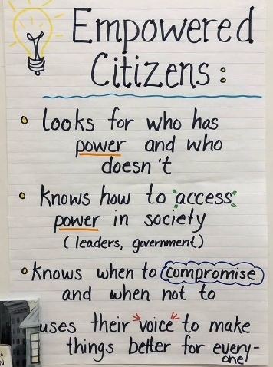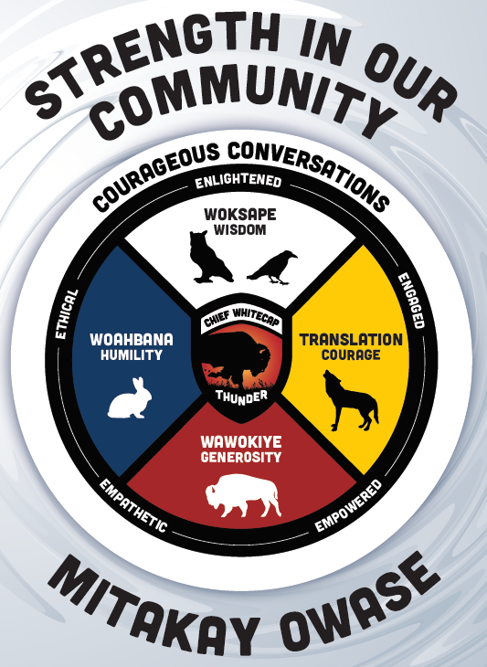
What Strategies of Instruction & Assessment Support Students
to Develop the Essential Citizenship Competencies? THE POWER 5!
The POWER 5: The Justice-Oriented Citizenship Educator’s Toolkit

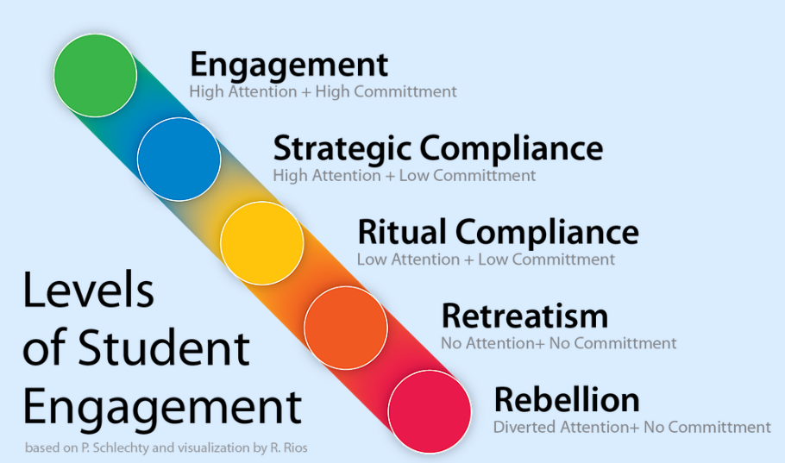
The Power 5 is a system of strategies which secures and sustains students’ authentic engagement in learning – a necessity for developing a justice-orientation.
Phillip Schlechty, Levels of Student Engagement.

Without authentic engagement, learning, even in a citizenship inquiry, can be reduced to an act of compliance

A student at each of the levels may be thinking . . .
Rebellion  “I don’t care what we’re doing and I’m disrupting others.” | Retreatism  “I don’t know what we’re doing so I’m not doing anything.” | Ritual compliance  “I understand what I’m supposed to do. I’ll do the minimum.” | Strategic compliance  “I don’t think this matters much but I’m going to do it as well as I can anyway.” | Engagement  “I think this matters a lot and I’m going to give it my best.”

This video further clarifies Schlechty’s Model.

While a student can develop academic proficiencies and earn high grades through compliance, they are unlikely to become committed to and adept at justice-oriented citizenship without authentic engagement. Moreover, it is not sufficient for some students and not others to experience authentic engagement – in a robust democracy, the equitable participation of all members of a community is the standard.

The Connection Between Authentic Engagement & Higher Order Thinking

Two of the key ingredients to engagement
According to John Hattie’s research, “teachers speak nearly 70% of the time in a typical classroom environment, with the rate rising in classrooms with ‘low-achieving’ students (Hattie, 2012).

with new learning in a classroom setting are:
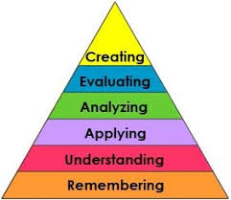
the level of thinking they are engaged in.

the number of people actively participating
in the thinking

HIGH LOW

The quadrants below represent the possible combinations of these ingredients:
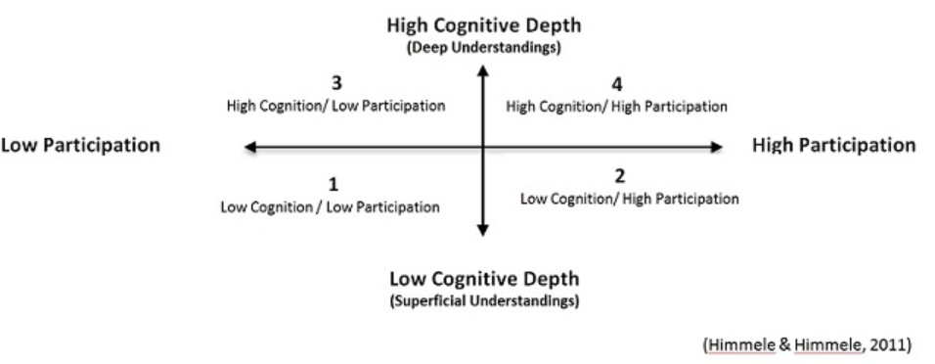
Power 5

QUADRANT 3 EXAMPLE  The teacher poses critical thinking questions to the class and calls upon students with their hands up to answer. | QUADRANT 4 EXAMPLE  Students engage in an essential question using a thinking routine and discursive strategy as the teacher circulates, focused on formative assessment & responsive instruction.
QUADRANT 1 EXAMPLE  The teacher gives instructions or reads notices or students are copying notes from the digital projector. | QUADRANT 2 EXAMPLE  The teacher asks factual recall questions using Kahoot and all students have phones!

The Power 5: Quadrant 4 Teaching & Learning
These 5 strategies can be designed into lessons and units. Even using one can make a tangible difference in student engagement, interaction, and knowledge construction. They are robust, culturally responsive, and anti-oppressive – up to the challenge of equitably supporting academically and culturally diverse learners as they engage in K-12 curricula.
Ensure that formative and summative assessment tasks imitate or double as acts of citizenship.
place learning targets in meaningful contexts and engage all learners in higher order thinking.

explicitly integrate the knowledge, skills, & dispositions of justice-oriented citizens into learning

scaffold student thinking & interaction as they engage in learning tasks.

facilitate students’ exploration of the root causes and possible remedies of issues and divisions.

Concentus Citizenship Education teachers
have reported that using The Power 5 has:
- increased their confidence in inquiry pedagogy across the curriculum
- supported their use of the Concentus Inquiry Learning Plans, and
- energized their classroom learning cultures.

These Resources Contain:
- Resources for Each Power 5 Element
- Power 5 Lesson and Unit Planning Templates
- A Video Library of Examples of Power 5 Strategies in Action

