This table was created to convey the 5 Essential Competencies (5 E’s) to students of varying ages and developmental levels. They are levelled in terms of complexity. Teachers in K-3 may choose to use Level 1 (picture symbols) when teaching the 5 E’s whereas a grade 8 classroom may choose to use the Level 4 definition. Some may also choose to use multiple (ex. Grade 6 may use a picture symbol from Level 1 paired with a hashtag #).

 | Level 1 | Level 2 | Level 3 | Level 4
Enlightened |  | #past&present  #learnmore | I can discover how the past connects to the present. | Historical events have an impact on today’s decisions and today’s understandings impact our perception and interpretation of historical and current events.
Empowered |  | #getconnected  #power | I can identify the rules and how they influence people. | Governance and public decision-making reflect rights and responsibilities and promote societal well-being amidst different conceptions of public good.
Empathetic | 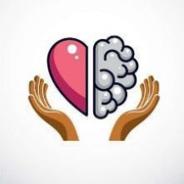 | #diversitystrong  #headsandheart | I can understand and respect how others think and feel. | Diversity is strength and should be understood, respected, and affirmed.
Ethical | 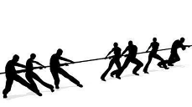 | #useyourvoice  #standupspeakup | I can see that we all have rights & responsibilities. | Canadian citizenship is lived, relational and experiential and in Canada, requires understanding of Aboriginal, treaty and human rights.
Engaged |  | #getinvolved  #dosomething | I can take actions to make the world a better place. | Each individual has a place in, and a responsibility to contribute to, an ethical civil society; likewise government has a reciprocal responsibility to each member of society.
Table created by Kaelyn Turberfield. Hashtags inspired by C. Toews.

